Ryan Farruggia

CSC 35

Professor Ghansah

17 March 2021

Lab Report #6

Image of source code with Main, DisplayW, GetInput, and CalculateW procedures displayed:

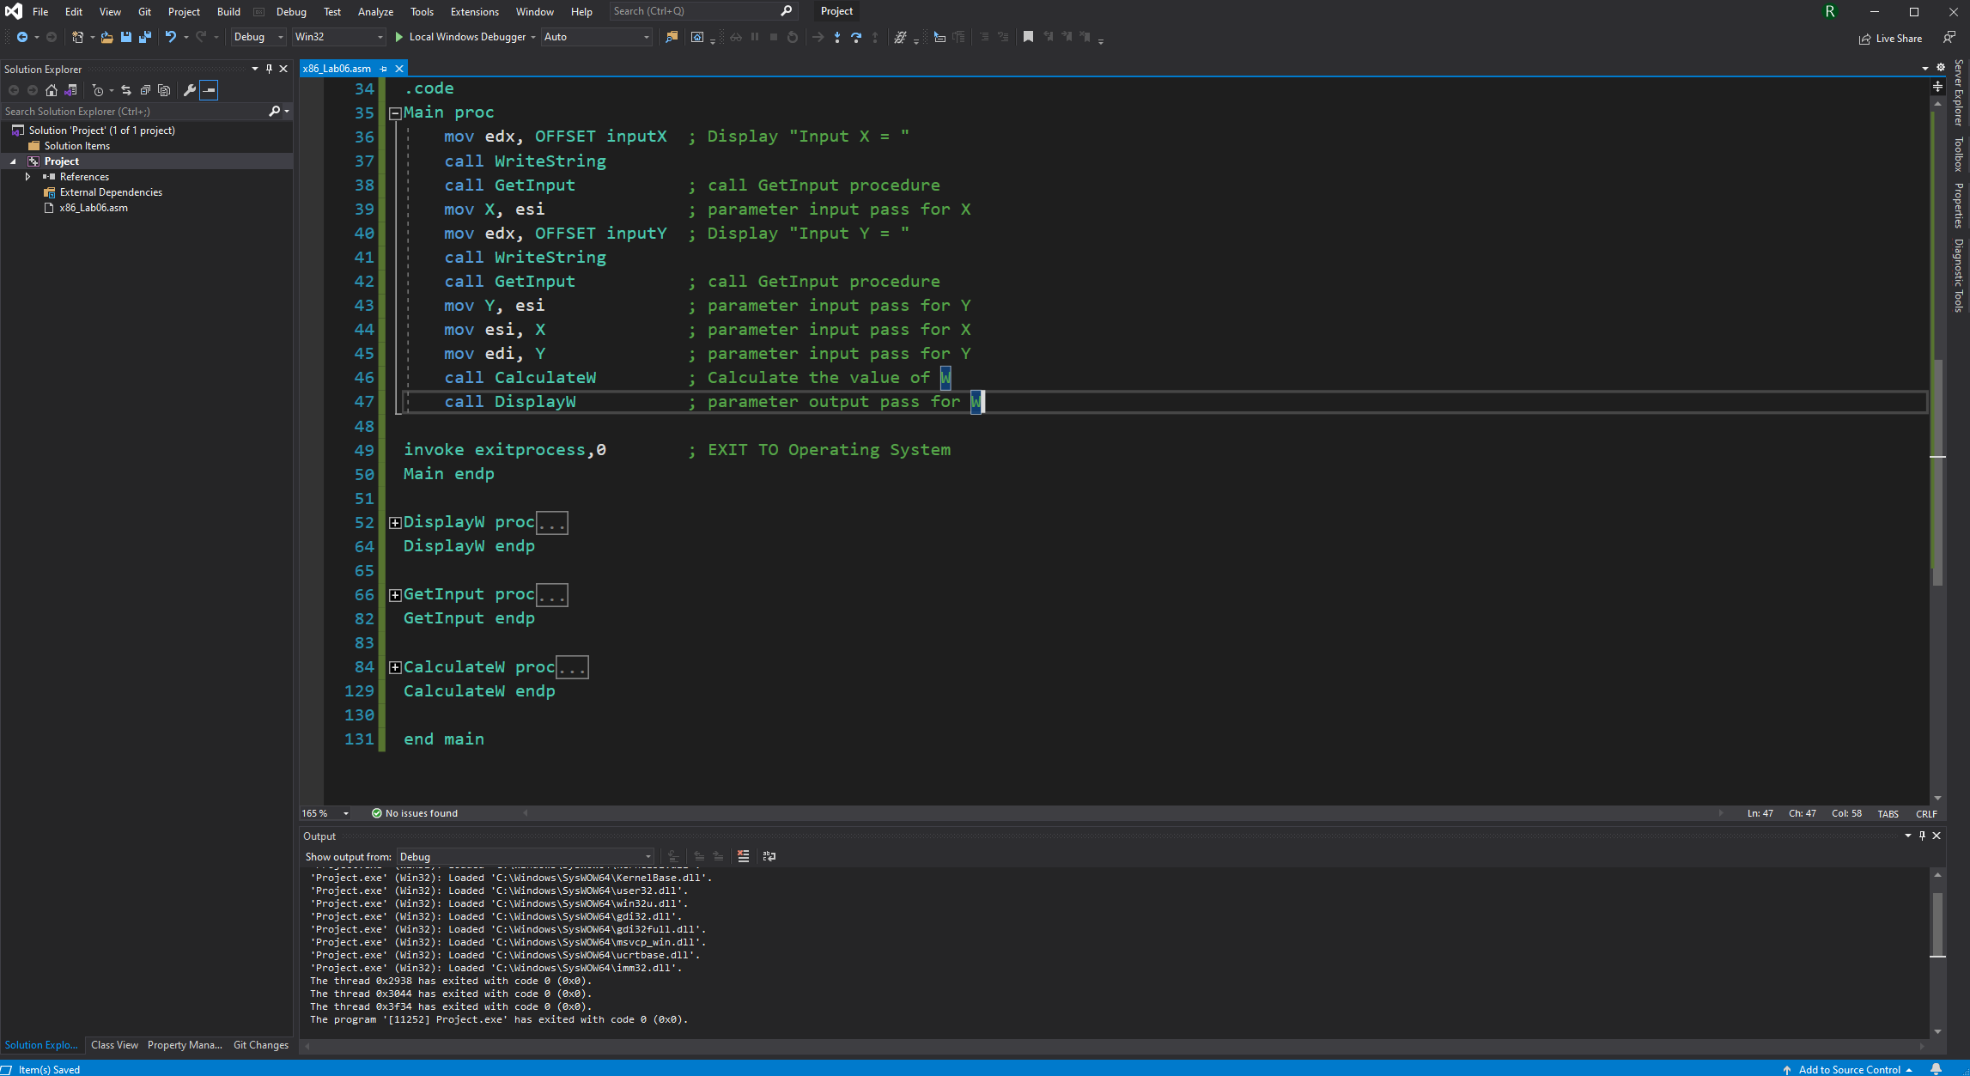

Image of first set of instructions and output in console:

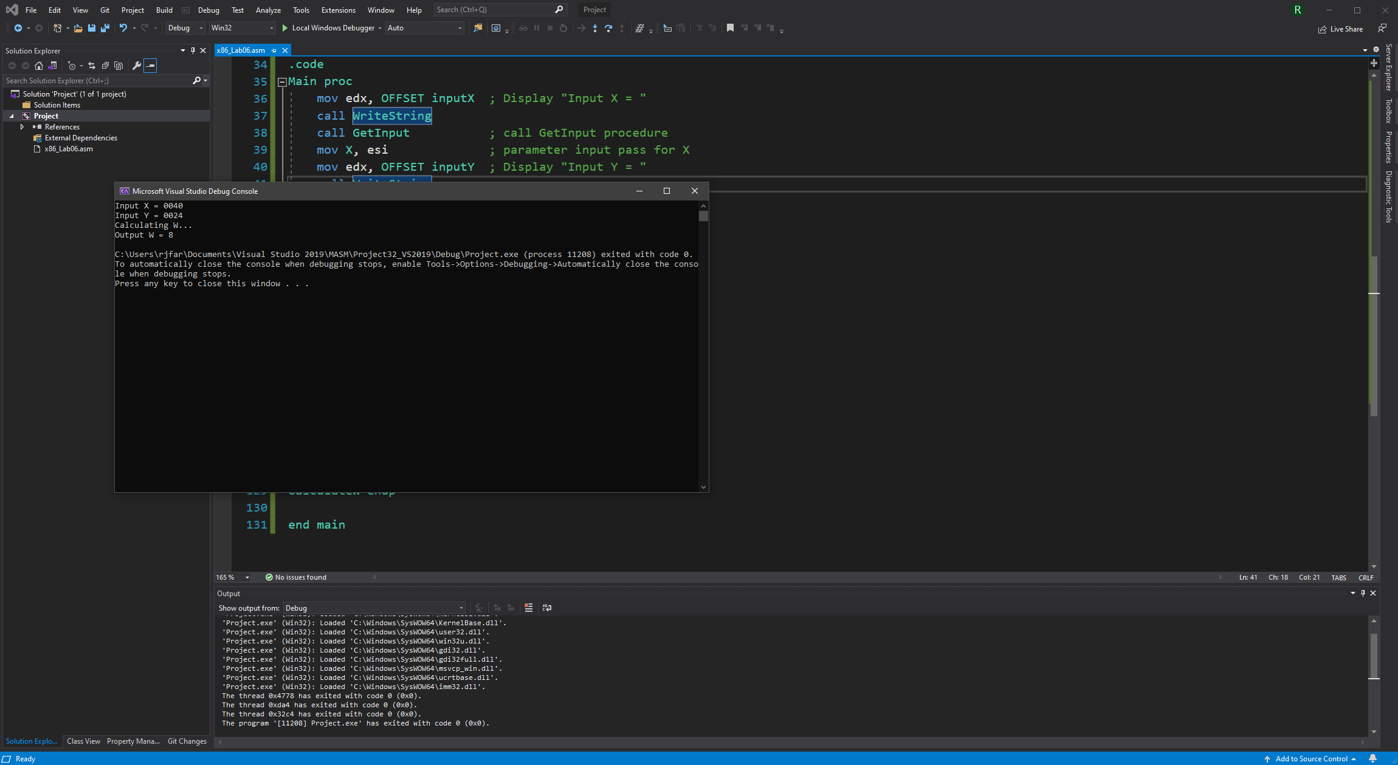

Image of second set of instructions and output in console:

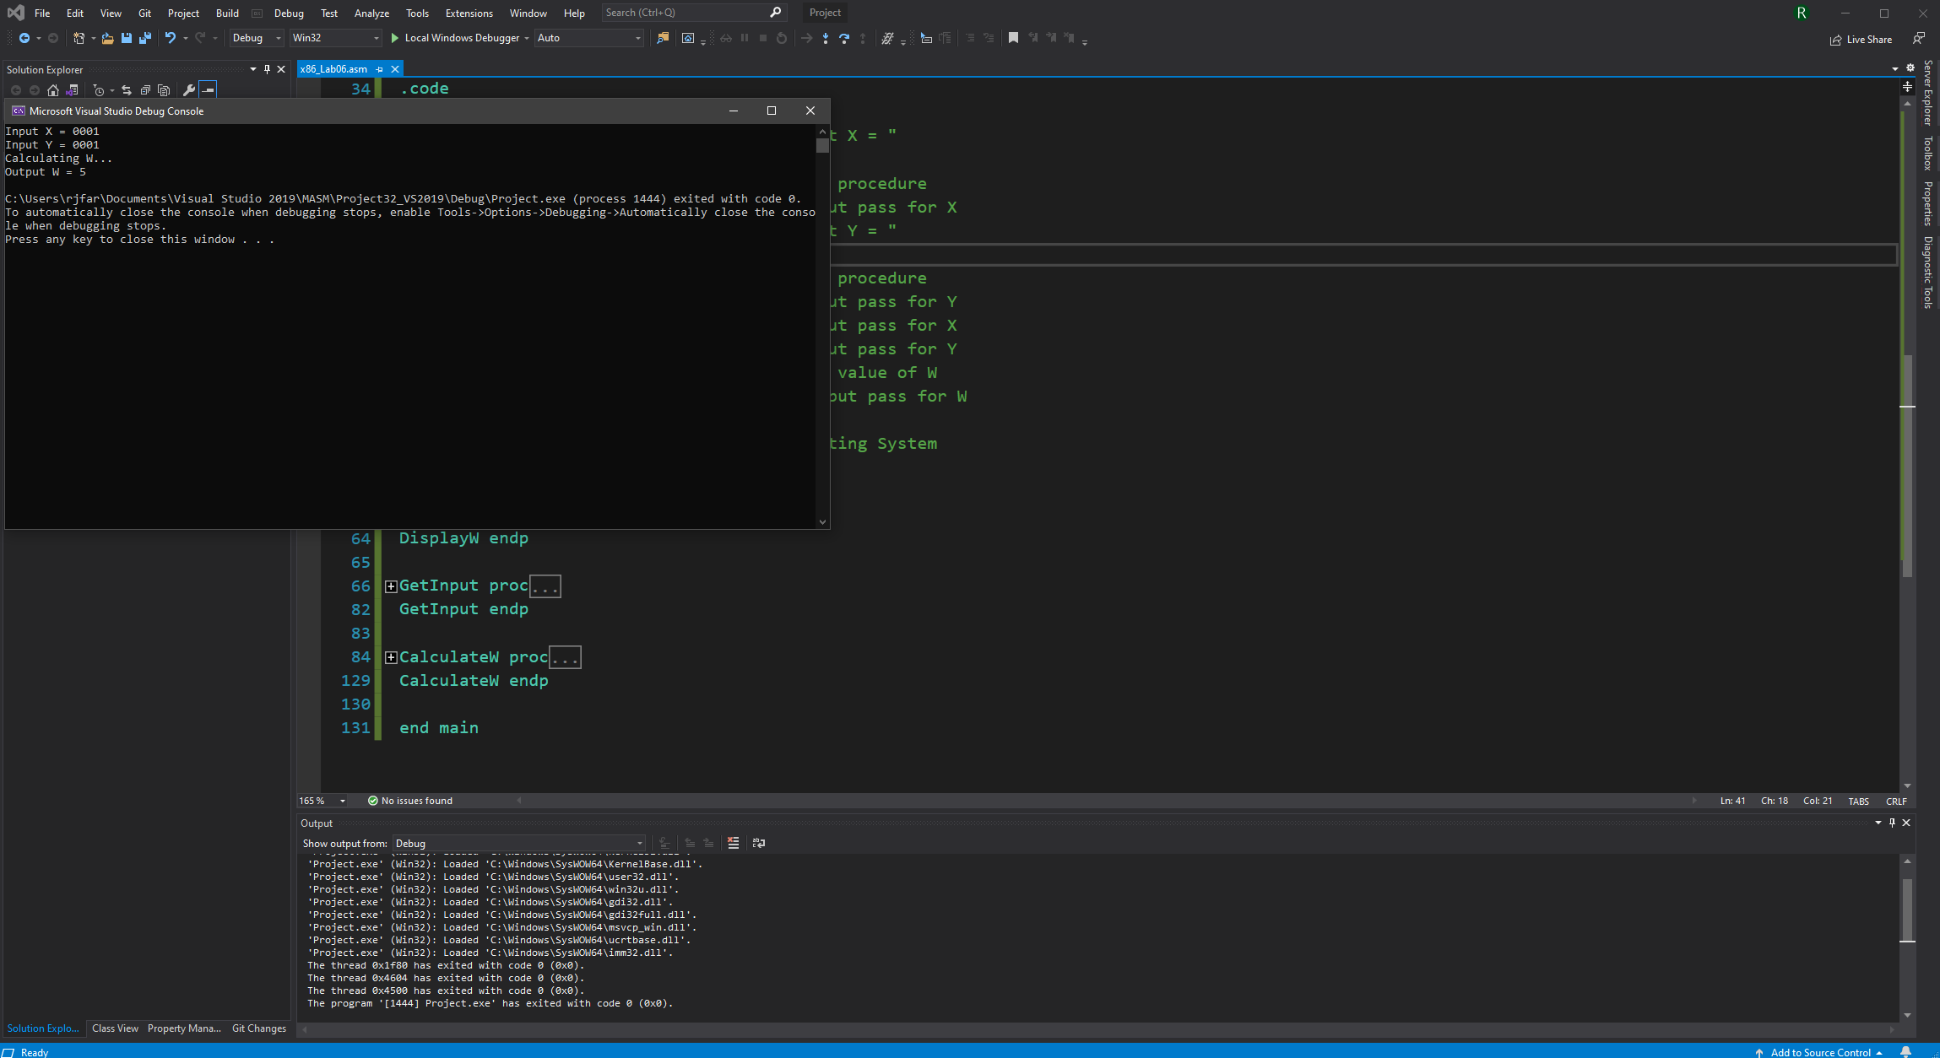

Image of third set of instructions and output in console:

